**MURANG’A UNIVERSITY OF TECHNOLOGY**



**INDUSTRIAL ATTACHMENT REPORT**

**BY**

**EDWARD MUTETHIA MURITHI**

**REG NO: SC150/0115/2022**

**ORGANIZATION ATTACHED: JEREMIAH NYAGAH NATIONAL**

**POLYTECHNIC**

**ATTACHMENT DURATION: 3 MONTHS**

*Industrial Attachment Report submitted to the School Of Computing and Information*

*Technology, Department of Information Technology in partial requirements for the award of a*

*Diploma in Information Communication Technology.*

# **DECLARATION**

I affirm that this work is a product of my own effort and has not been submitted or presented elsewhere for academic credit. It is intended solely for evaluation in fulfillment of the requirements for ICT Technician Level 6.

# **ACKNOWLEDGEMENT**

I am deeply grateful to God for granting me the strength and opportunity to successfully complete this attachment. My heartfelt appreciation goes to my host supervisors, Mandam Catherine Ngari, Mr. John Murangiri, and Mr. Njagi, for their invaluable guidance and encouragement throughout the period. I also wish to thank the entire team at Jeremiah Nyagah National Polytechnic for their unwavering support and involvement in all ICT Technician-related activities. Finally, I sincerely thank my family and friends for their continuous love, encouragement, and moral support — their presence has been a pillar throughout this journey.

**EVIDENCE OVERVIEW**

The purpose of this evidence is to provide the details of the industrial attachment, a description of all the activities undertaken, skills gained and challenges during the attachment period. The purpose of attachment is to put all the theoretical work done in class into practical exercise.

I did my industrial attachment at Jeremiah Nyagah National Polytechnic for a period of three months. The major activities I carried out include providing support services to the organization staff, Teaching Core Units such as Programming, Software installation and Maintenance, Registering Knec students for the students preparing the classes for e-learning, that is, connecting LCD projectors or the public address, configuring routers, setting up IP phones, terminating and connecting Ethernet cables, installing various System software (Operating systems and Utilities) and Application software’s on desktops for example, Compilers, Office tools, printing out internal exams, and troubleshooting several devices when need arose and also editing the timetable courses for the evaluation after the end of a course.

**TABLE OF CONTENTS**

**DECLARATION** **1**

**ACKNOWLEDGEMENT** **2**

**CHAPTER ONE** **1**

**1.0 INTRODUCTION** 1

**1.1 Background of the Attachee** **1**

**1.2 Objectives** **1**

**1.3 Main functions and core activities of Jeremiah Nyagah National Polytechnic** **1**

**1.3.0 ICT Department** **2**

**CHAPTER TWO** **1**

**2.1.1 Numeracy Skills** **1**

**2.1.2 Digital Literac**y 1

**2.1.3 Environmental Literacy** **1**

**2.1.4 Employability Skills** **1**

**2.1.5 Occupational Safety and Health (OSHA)** **1**

**CHAPTER THREE** **3**

**3.0 Graphic Design** 3

**3.1 I covered the following areas:** **3**

**CHAPTER FOUR** 4

**4.0 REPAIR, MAINTENAMCE AND MANAGE INFORMATION SYATEMS** **4**

**4.1.1 Computer Hardware and ICT equipment maintenance** 4

**4.1.2 Printers and toners** **4**

**4.1.3 Computer Motherboard components** 5

**CHAPTER FIVE** **6**

**5.0 INSTALL COMPUTER SOFTWARE AND ICT SYSTEM SUPPORT** 6

**5.1.1 Data Back up and restoration** **6**

**5.1.2 Software installation** 8

**5.1.3 Software upgrade** **12**

**5.2.1 LAN Cabling and maintenance**  **12**

**CHAPTER SIX** **14**

**6.0 SUMMARY** 14

**6.1 PROBLEMS ENCOUNTERED AND HOW I OVERCAME**  **14**

**6.2 CONCLUSION** **15**

**6.3 RECOMMENDATION** **15**

**6.4 REFERENCES** **15**

# **CHAPTER ONE**

## **1.0 INTRODUCTION**

* The industrial attachment is part of the curriculum of Evidence that lasts for a maximum of 3 months. This helps the student apply the theoretical skills gained throughout the academic period into practice. It also exposes the student into the practical work field to enable one gain the necessary skills and etiquette required in the work field. The industrial attachment also prepares one on how to tackle challenges faced in the work field and to gain a sense of responsibility in accordance to the tasks carried out.

### **1.1 Background of the Attachee**

* I joined the Murang’a University of Technology in the year 2022, where I took a course in Information Communication & Technology Level 6. I took the course for two and half years and thereafter did an industrial attachment in relation to the course.

### **1.2 Objectives**

**Some of the expectations from the attachment include:**

* To assess the interest of the student in the occupation he or she has been studying and is to undertake.
* To expose the students to work methods that might not have been taught in the college and to provide access and products equipment not normally available in the environment of the university.
* To provide the students with an opportunity to apply the knowledge in real work situation thereby closing the gap between university work and the actual practice.
* To make the transition from school to the world of work smoothly and to enhance contacts for job placement.
* To enlist and strengthen employers involvement in institutional activities and in their educational process of preparing the students for employment in the industry.
* To enhance industry’s satisfaction with the graduate of the faculty in particular and the university at large.

### **1.3 Main functions and core activities of Jeremiah Nyagah National Polytechnic**

* Jeremiah Nyagah National Polytechnic provides learning and development programs to build capacity for the Public Service by doing the following:
* Provide training, consultancy and research services designed to inform public policy, promote national development and standards of competence, and integrity in the public service.
* Promote continuous learning for public service excellence.
* Provide programs that promote a culture of decency, honesty, hard work, transparency and accountability among public servants.
* Facilitate the establishment of professional networks and think tanks to develop and grow public sector leaders.
* Develop linkages and collaborations with institutions of learning, professional organizations, private sector, schools of government and other similar institutions across the world.
* Monitor, evaluate and communicate the impact of strengthened education and training programs for national leadership and management.
* Develop and deliver programs tailored to promote the school’s mandate and client’s needs.
* Conduct examinations and award diplomas and other forms of suitable awards to successful candidates.

#### **1.3.0 ICT Department**

**The following are the function of the ICT Department in Jeremiah Nyagah National Polytechnic:**

* To provide, coordinate and facilitate the use of technology and information resources to the satisfaction of the organization and its stakeholders.
* Improve and maintain ICT infrastructure in the organization.
* Promote use of Management and Organization Support Information Systems.
* To provide user support and ICT Equipment Maintenance.
* Develop Business Continuity Plans.
* Enforce and implement e-Government standards and procedures.
* Leverage on ICT to foster innovation for business processes.

Manage ICT use and security issues in a comprehensive and coordinated way

# **CHAPTER TWO**

**2.1 Evidence summary**

* I participated in teaching key foundational units that are essential for student development and workplace readiness. These units included:

### **2.1.1 Numeracy Skills**

* I assisted learners in solving real-life mathematical problems involving percentages, ratios, measurements, and basic statistics. I guided them through practice exercises, group discussions, and marked their work.

### **2.1.2 Digital Literac**y

**Introduced students to basic computer operations.**

* Typing, internet usage, email communication, and safe online practices. I also demonstrated how to use productivity software like Microsoft Word and Excel.

### **2.1.3 Environmental Literacy**

* I taught students about the importance of environmental conservation, proper waste disposal, and sustainability practices. We discussed real-world issues like pollution and climate change.

### **2.1.4 Employability Skills**

* I guided students on essential soft skills such as communication, teamwork, time management, and problem-solving. We also discussed workplace behavior, appearance, and interview preparation.

### **2.1.5 Occupational Safety and Health (OSHA)**

* I sensitized students on workplace hazards, safety signs, emergency procedures, and the importance of using Personal Protective Equipment (PPE). Practical sessions included identifying safety risks in a computer lab or workshop environment.

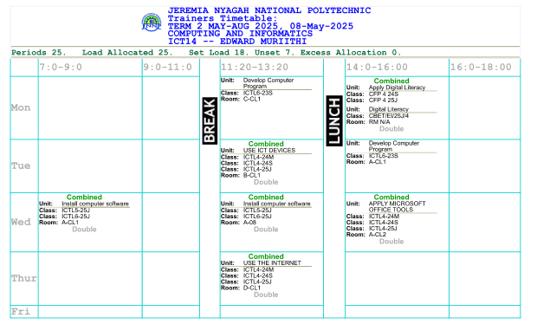

# **CHAPTER THREE**

## **3.0 Graphic Design**

* I participated in introducing and guiding students on Graphic Design during their first Cultural Week. The objective was to help them understand how to use digital tools to create posters, banners, and visual content related to cultural activities and themes.

### **3.1 I covered the following areas:**

* Basics of graphic design principles (layout, color, balance, typography)
* Hands-on use of design software such as CorelDraw and Adobe Photoshop
* Designing posters and digital flyers to promote Cultural Week events
* Encouraging creativity while aligning with the event's cultural themes
* Assisting students in printing and displaying their design.This activity helped learners apply their digital skills in a real event while promoting cultural expression and teamwork through design.



# **CHAPTER FOUR**

## **4.0 REPAIR, MAINTENAMCE AND MANAGE INFORMATION SYATEMS**

### **4.1.1 Computer Hardware and ICT equipment maintenance**

* Involved regular and routine activities like computer and printer blowing to remove dust particles that settle on computer and printer components thus clogging, replacing of printer toner cartridges, solving printer paper jam issues, replacing faulty computer fans that could derail computer booting, troubleshooting and replacing faulty computer hard disks, replacing faulty UPS, power cables and power supplies.

### **4.1.2 Printers and toners**

* When replacing a toner, pay attention to the size of the cartridge, else it will not fit into the printer toner assembly. To add a network printer to the network, go to devices and printers, click on add printer, then wait for it to search and when it does, click on it and print a test page just to be sure that you have done the right thing.

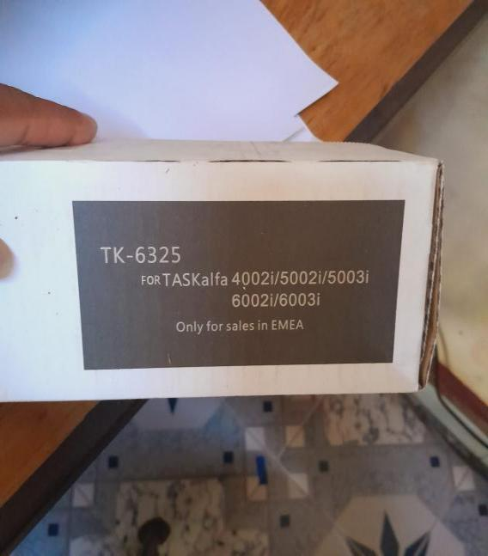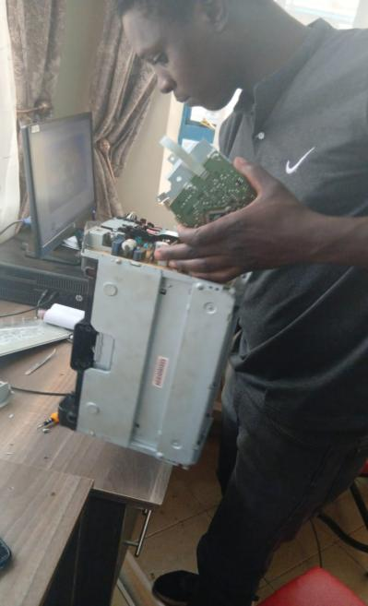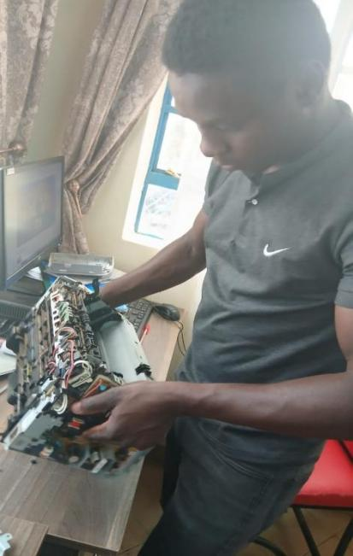

### **4.1.3 Computer Motherboard components**

* When the CMOS battery is low, the computer keeps losing time and date which in turn greatly affects the timetable, which is found on the motherboard. On the same motherboard is a reset button which can be used to reset it. Also, there is a tiny device called a jumper, which when plugged into another set of jumper pins makes an extra added storage device readable in a process called enslavement. The SATA bus is used to read a hard disk when plugged alongside the power cables from the power supply.

# **CHAPTER FIVE**

## **5.0 INSTALL COMPUTER SOFTWARE AND ICT SYSTEM SUPPORT**

* Understanding Operating Systems involved activities such as software installation, configuration and upgrading.

### **5.1.1 Data Back up and restoration**

* I performed data backup and restoration as part of replacing a computer's Hard Disk Drive (HDD) with a Solid State Drive (SSD). The main purpose of the backup was to ensure that no important files or system data were lost during the hardware upgrade.

**This involved:**

* Identifying and backing up all user data and system files from the old HDD
* Using external storage or cloning software to transfer data
* Installing the SSD and restoring the data back onto the new drive
* Verifying that the system and files worked correctly after restoration
* This process helped improve the computer's performance and demonstrated the importance of secure data handling during hardware upgrades

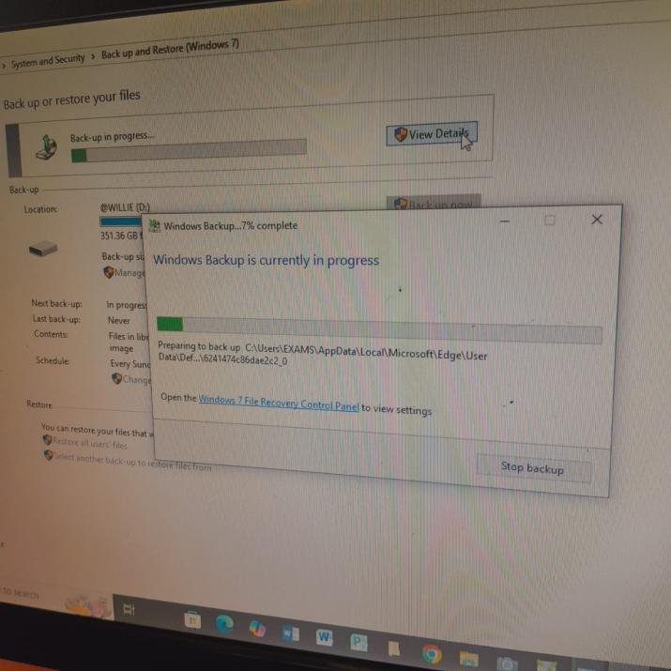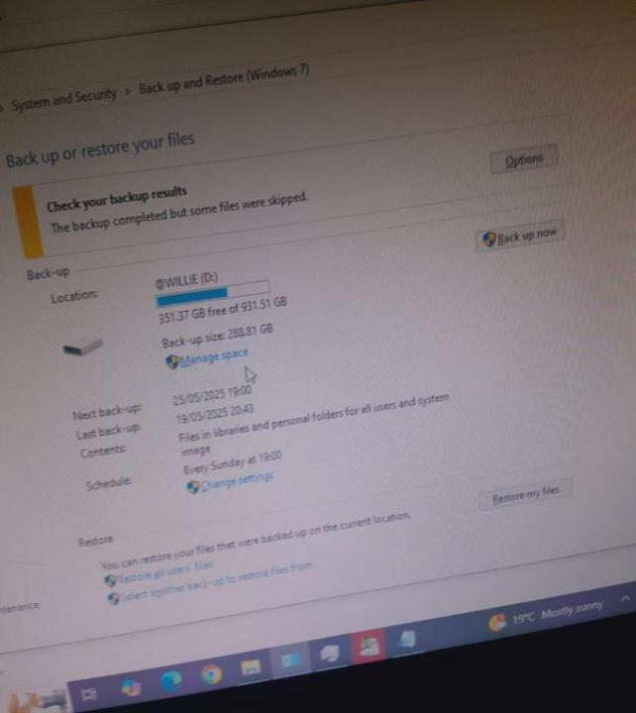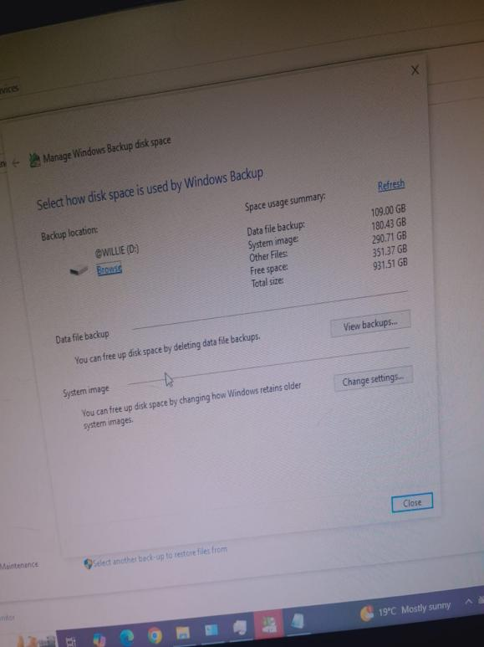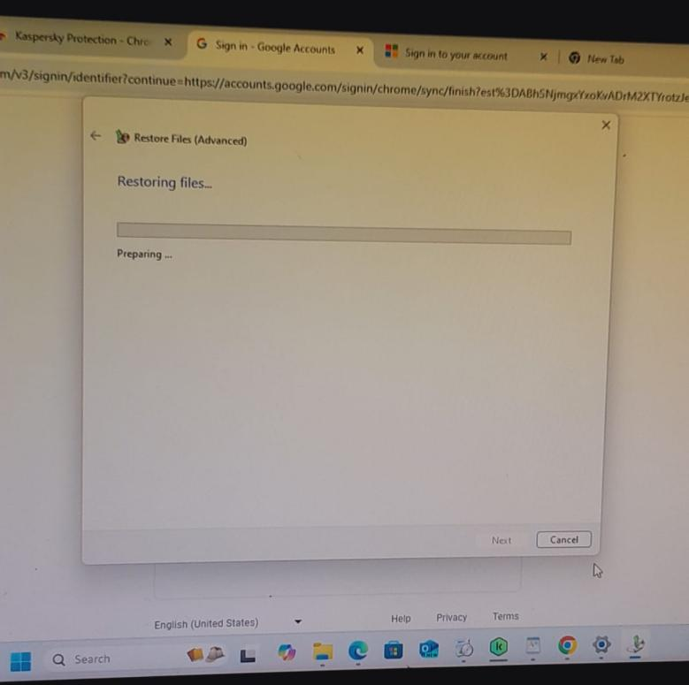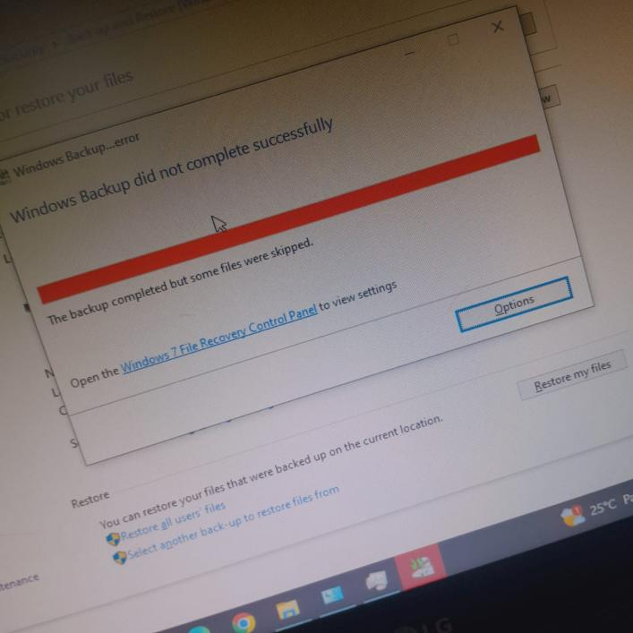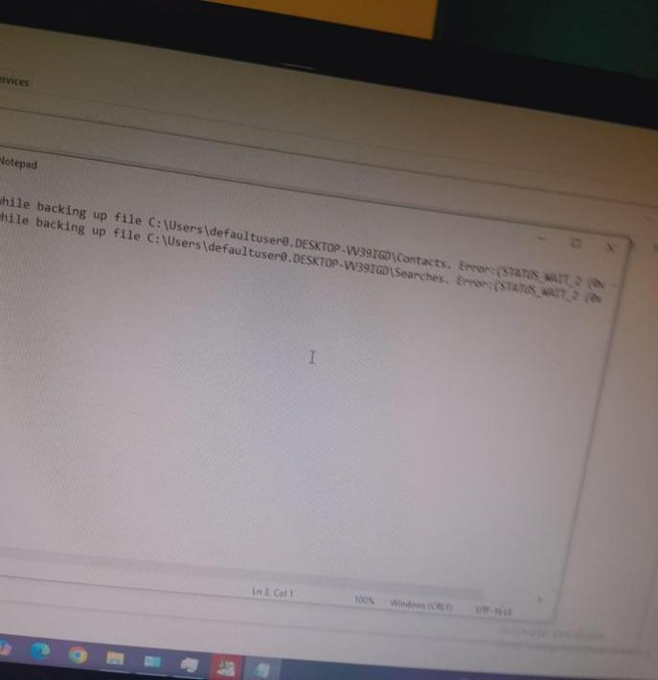

### **5.1.2 Software installation**

**Windows Operating System**.

* This is mostly used to upgrade the existing one to a later version, installing afresh on a new computer or after formatting to get rid of the previous faulty or out dated one. To do so;
* Plug in your boot device (DVD ROM, Flash Disk or Hard Disk) that contains the windows 10 set up files on it and boot/reboot the computer.
* Click on the install option that pops up, select the version of windows you want
* Accept the terms and license, skip the product key option if you don’t have one
* If multiple unnecessary partitions existed, delete them and remain with/ edit the appropriate ones
* Automatically, all the required files are copied and windows OS installed.

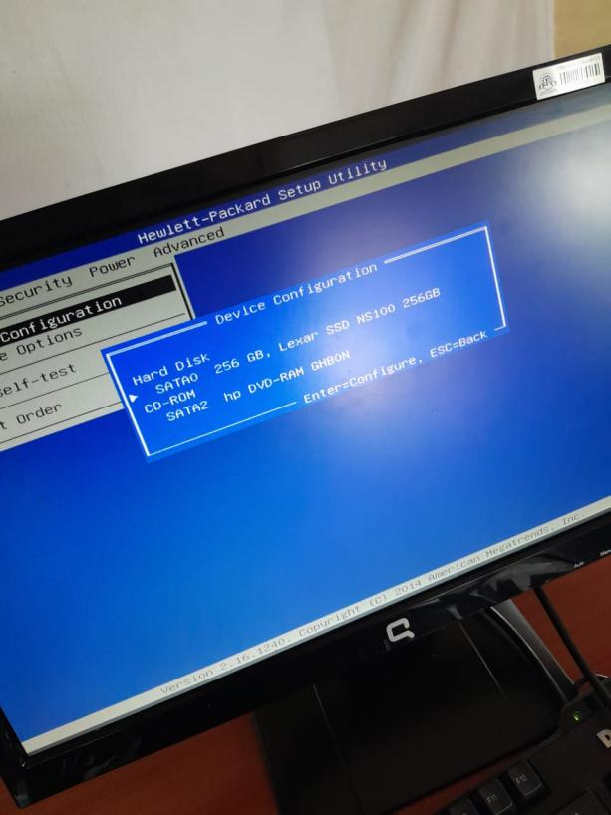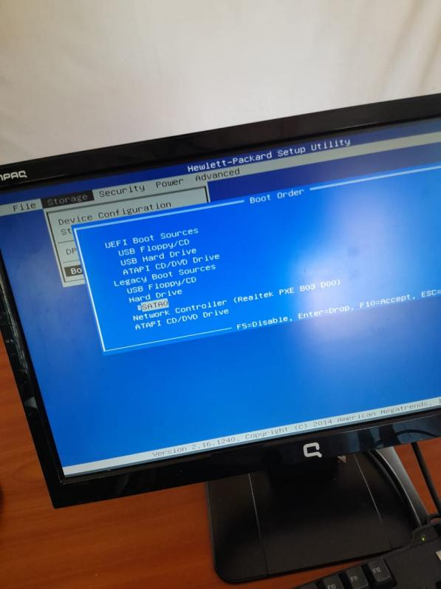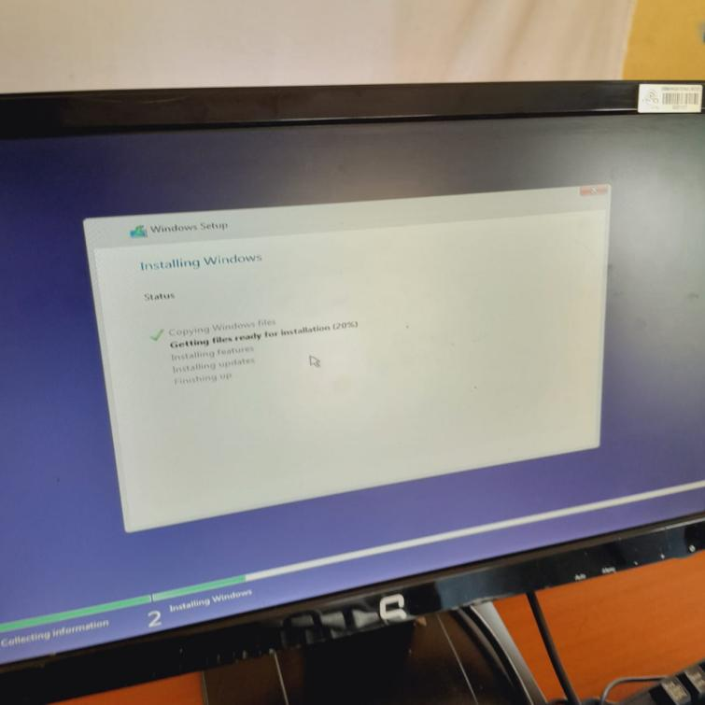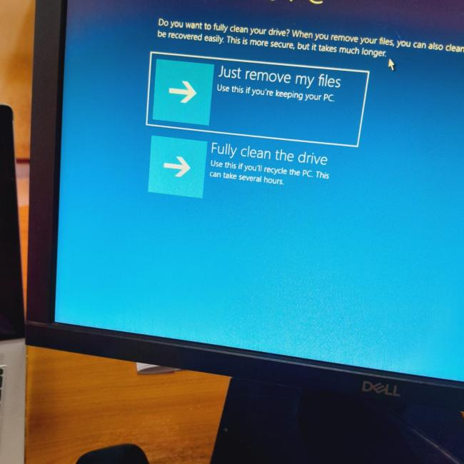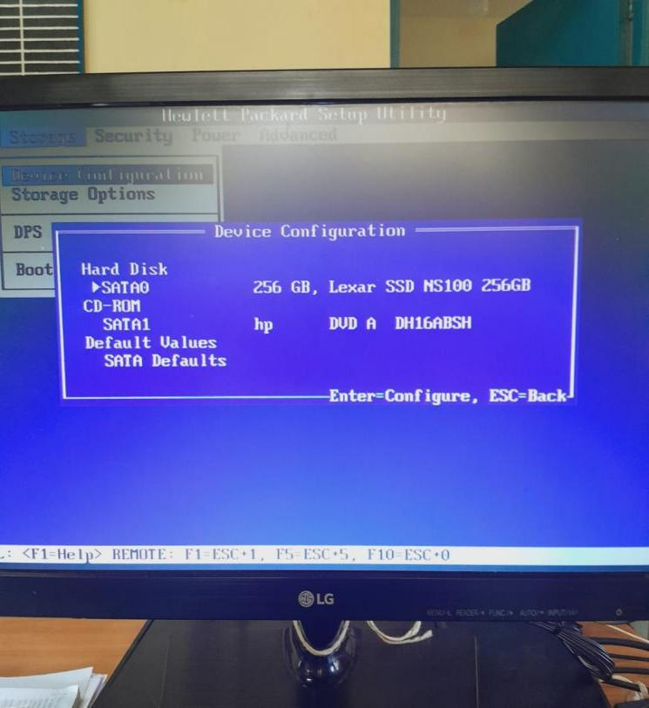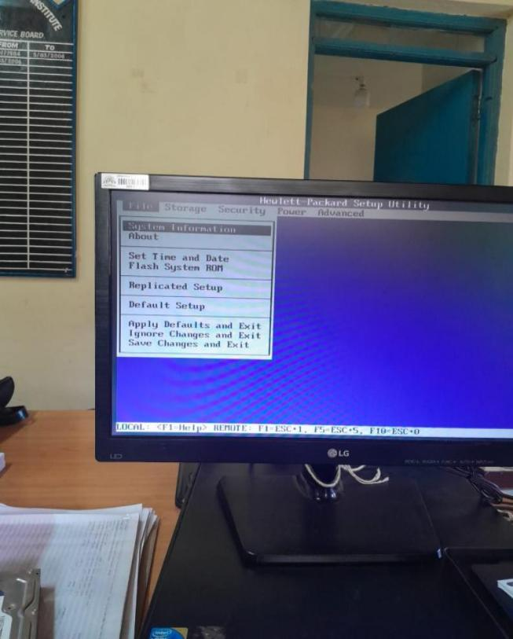

**Fedora Linux**

* Just like in windows installation, follow the preliminary steps and follow the prompts. However, you have to select on the “customize now” option over the “customize later” one.
* As well, select the GNOME option. GNOME is a sleek interface that is built with developer feedback and minimizes distractions so you can concentrate on what’s important.

**Kaspersky Antivirus**

* An antivirus is designed to detect and destroy computer viruses. Kaspersky Antivirus is the one I used all the time.
* **Download the Installer**

Visit the official Kaspersky website: https://www.kaspersky.com

Navigate to "Premium" under the Products section.

Click Download and save the installer to your computer.

* **Run the Installer**

Locate the downloaded file (usually in the Downloads folder).

Double-click it to run the installer.

* **Allow Installation**

If prompted by Windows (User Account Control), click Yes to allow the app to make changes.

* **Start Installation**

The Kaspersky Setup Wizard will launch. Click Install.

Wait for the software to download required files and install (internet connection required).

* **Read and Accept Agreements**

Agree to the License Agreement and Privacy Policy.

* **Sign in to Your Kaspersky Account**

After installation, it will prompt you to sign in or create a My Kaspersky account.

This is required to activate your license and manage your devices.

* **Enter Activation Code**
* If you already bought Kaspersky Premium, enter the activation code provided after purchase. Once activated, the software will start up.Run a Quick Scan or Full Scan to check for threats.

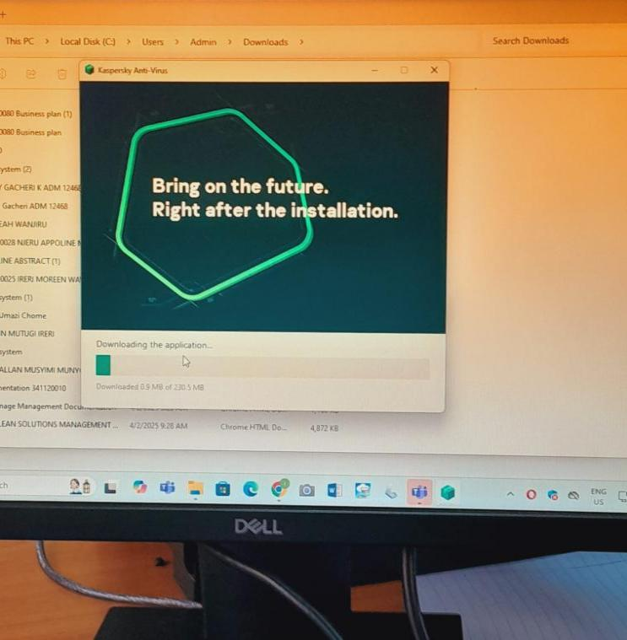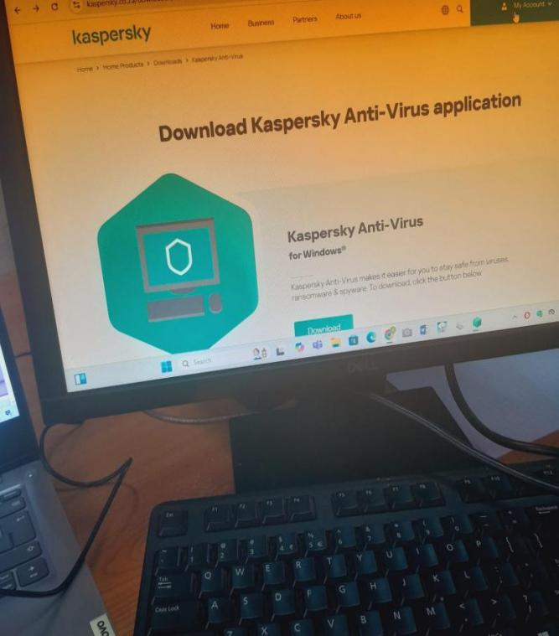

.

### **5.1.3 Software upgrade**

* This only came into play when upgrading a windows 7 to windows 10 pro as well as the antivirus.

**5.2 Network Configuration and Maintenance**

* Most computers received their network configurations dynamically through the DHCP. However, sometimes devices shared IP addresses and I was forced to configure them statistically to get them back to the network since to operate the ERP system a user had to be connected to the network to successfully log in to their account, otherwise it flagged errors, although most of the time drivers got corrupted or deleted due to power surges.
* On windows go to the command prompt and ping the default gateway and if it returns TTL packets, then check the Ethernet cable and port and subsequently the robustness of the LAN card or PCI, that is, if host is unreachable then go ahead to statically configure it. Click on the network icon, Ethernet, change adapter options, properties, use the following IP, then enter the unique IP address, subnet mask and the default gateway. Below it, enter the primary and secondary DNS server then validate settings.

### **5.2.1 LAN Cabling and maintenance**

**Cable Termination**

* This mostly had to do with making a new patch cord for office use or terminating a CAT 6 when connecting a new work station to the nearest switch.You can terminate in two forms, straight through, used when connecting two different devices like a switch and computer, or in cross over, used when connecting two same devices like a switch and a switch.To terminate a cable, you need two RJ45 connectors, a CAT 6 and the climping tool. Using the bladed end of the tool, gently strip the cable about an inch and half from the end.Then arrange the twisted pairs according to your desired format;
* **Straight through -** Brown, brown-white, green, blue-white, blue, green-white, orange, orange-white
* **Cross over -** Brown, brown-white, orange, blue-white, blue, orange-white, green, green-white
* Then, carefully insert the arranged cables into the RJ45s on each end then place them in the corresponding holes in the climping tool until they touch the protruding metal ends then gently squeeze the handles of the tool to get the RJ45s climped.

**Creating a data point**

You will need a module, a UTP CAT 6, a patch panel, a crimping tool and a punch down.Gently strip the cable using the tool, then in reference to the color code on the module, arrange them into the respective slots. Remember to keep the color code consistent on both sides of the module because there are two on each side, the top and bottom one.Then using the punchdown, punch them deeper down into the module slots. Then, using the tool, cut the hanging twisted pairs from outside then cover them using the module cap. Fit it in the patch panel and screw it to the wall or trunks.

**Network Switch and server Management**

* The most common switch in the organization was the Catalyst 2960, 4507series and NETGEAR. However, that was for LANs mostly. From the service providers, the network is dropped to the Cisco router 800 series and an Edge-router in the server room, in which it has a cyberoam which acts as a default gateway. From there it is then connected to the COR switch which then distributes it to other departments through fibre optic cables. They are classified into;
* **Single Mode -** Travels for longer distances of up to 80 km, is cheaper but slower compared to multimode.
* **Multimode -** Travels for shorter distances of up to 5 km, is more expensive and faster compared to single mode.
* Distribution occurs at the rack which come in different sizes such as 9U, 27U, 42U and 48U. The cables are labelled according to corresponding ports on the racks. At the top of the rack is the Optical Distribution Frame(ODF). When the fibre optic gets terminated at the ODF it is plugged in to the Small Form-factor Pluggable (SFP), a small swappable transceiver on the switch . The cladding is stripped and splicing occurs to enable more ports to be connected. Data is transmitted in form of an optic beam.When a switch fails, it can be configured remotely by using the Anydesk application to log in to PuTTY. Else, the network admin can go to the server room and troubleshoot it manually. In some cases we had to restart the switch using a LAN key. The switch has two power supplies, one of which is a back-up in case the current one fails. A managed switch has admin privileges and needs authentication to access the configurations and maybe change them. An unmanaged switch is just a plug and play device without any authentication needed to access it.The star topology is preferred to the ring and mesh topology because of easier fault location and also its robustness of a failure in one device not affecting others from functioning.

# **CHAPTER SIX**

## **6.0 SUMMARY**

* The Industrial attachment seeks to offer students a practical translation of the theory that they have been taught. It has also got individual benefit of liasing the university to the industries, hence brightening the employment chances of the students in the university. Through this attachment, I have gained field skills and generated a good interpersonal relationship through my interaction with my supervisors and colleagues. This has assisted me to interact confidently with the staff and colleagues irrespective of the position.
* The various activities include:
* Configuring network printers and other resources
* Adding and sharing a local printer.
* Administering network printers
* Managing the paper jams.
* Networking components
* Hardware
* Software
* Media
* Server/Clients
* Wireless media
* Switch
* Modem and access points.
* Setting up LAN
* Preparation of networking cables
* Testing connectivity
* Connecting LAN to the internet

## **6.1 PROBLEMS ENCOUNTERED AND HOW I OVERCAME**

* Under ration from other staff who simply thought we were clueless and kept insisting that we should call the supervisor or the ‘in charge’. We went on ahead to solve the problems through inquiry and team work.
* Some computers were too old and slow and kept breaking down constantly. We tried as much as we could to do constant maintenance like blowing them.
* There were too many of us at a go which made the training exercise tedious but successful, nevertheless. We overcame it through turn taking and rotations.
* Lack of trust from the organization’s senior employees.

## **6.2 CONCLUSION**

The attachment has been an excellent and rewarding experience. During the three months of attachment period, I got a lot of exposure in the field of ICT through carrying out various activities. I have also received experience in maintaining proper workplace etiquette. Respect of hierarchy and integrity is a core value that determined the successful completion of the attachment. I have also got feedback from clients and staff that has helped me evaluate myself and know where I am weak at and my strengths too.

## **6.3 RECOMMENDATION**

Cable Management: All data cables should be we labeled and tagged for proper identification and well placed in the metal trunk.

Training program should be started for both academic and administrator staff.

Most of the computers used have lower space in terms of memory (RAM) and hard disk space hence cannot support heavy applications. The machines should be upgraded if not replaced with new machines.

## **6.4 REFERENCES**

1. Jeremiah Nyagah National Polytechnic